EXPERIMENT 1: DATA PREPROCESSING
AIM:
To preprocess a dataset by identifying missing values, filling missing numerical values with their mean, and standardizing numerical features using StandardScaler.
ALGORITHM:
- Import Pandas and StandardScaler.
- Load the dataset from data.csv.
- Display the first five rows of the dataset.
- Check for missing values in each column.
- Fill missing numerical values with their respective column means.
- Select the numerical columns Hours_Studied, Attendance, Assignments, and Marks.
- Apply StandardScaler to standardize the selected features.
- Convert the standardized data into a DataFrame.
- Display the first five rows of the normalized dataset.
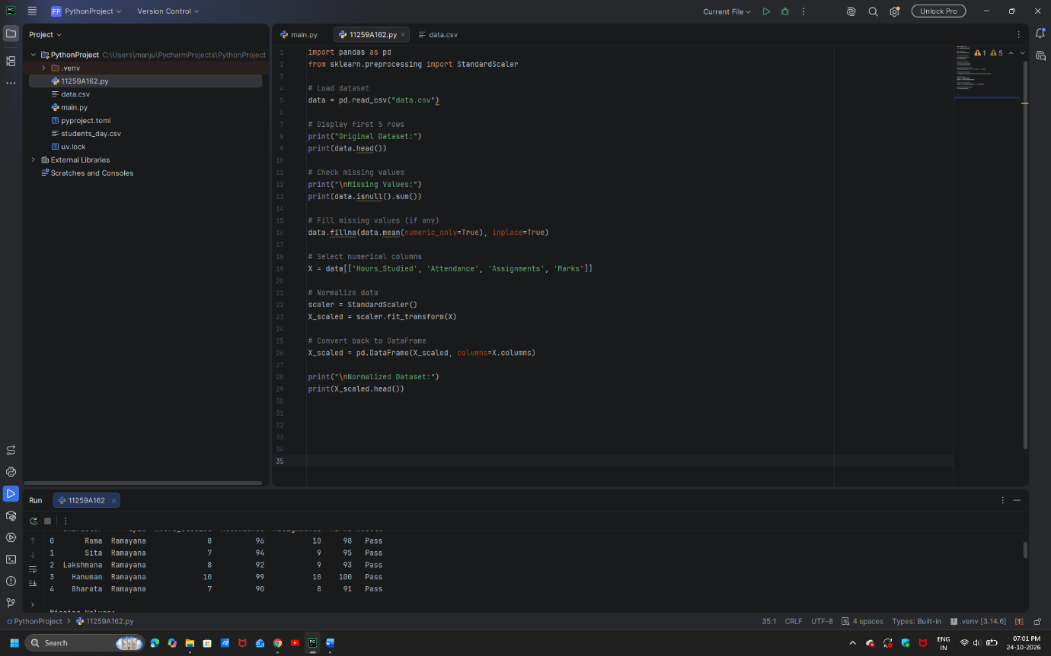

RESULT:
The dataset was successfully preprocessed by handling missing numerical values and standardizing the selected numerical features.

EXPERIMENT 2.1: DATA SPLITTING
AIM:
To split a dataset into training and testing sets using the train_test_split() function.
ALGORITHM:
- Import Pandas and train_test_split.
- Load the dataset from data.csv.
- Select Hours_Studied, Attendance, and Assignments as input features.
- Select Result as the target variable.
- Split the dataset into 80% training data and 20% testing data.
- Set random_state=42 to ensure reproducibility.
- Display the training data and testing data.
- Display the number of training and testing samples.

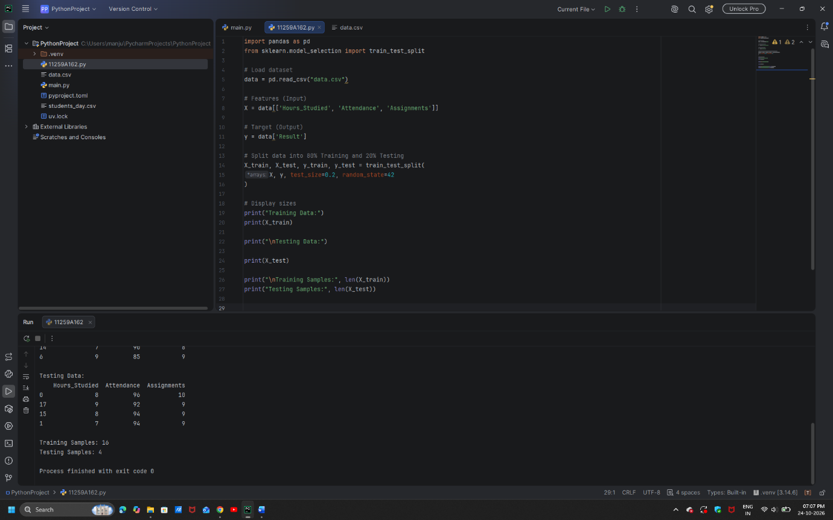

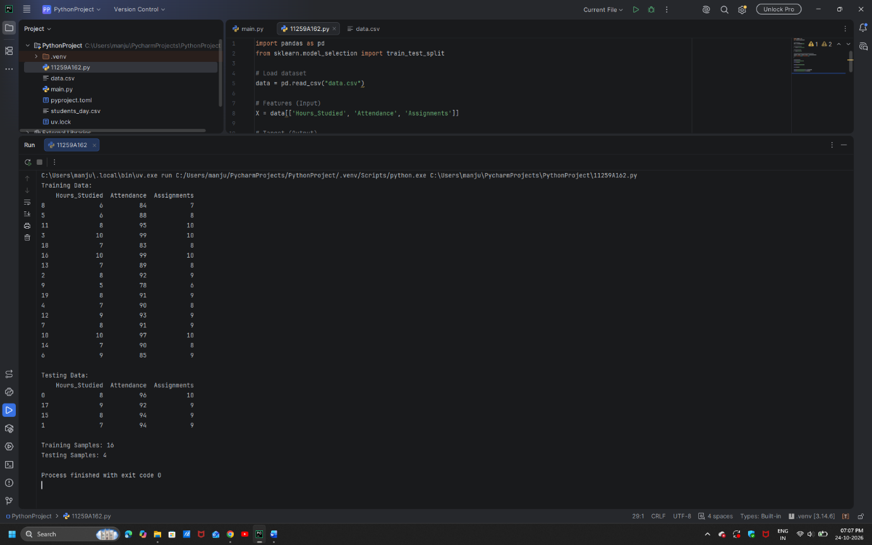

RESULT:
The dataset was successfully divided into training and testing sets in an 80:20 ratio.

EXPERIMENT 2.2: Data Split up and Cross validation.
AIM:
To evaluate a K-Nearest Neighbors (KNN) classifier using five-fold cross-validation.
ALGORITHM:
- Import Pandas and the required Scikit-learn modules.
- Load the dataset from data.csv.
- Select Hours_Studied, Attendance, and Assignments as input features.
- Select Result as the target variable.
- Split the dataset into training and testing sets in an 80:20 ratio.
- Create a KNN classifier with n_neighbors=3.
- Perform five-fold cross-validation using cross_val_score().
- Display the five cross-validation scores.
- Calculate and display the average accuracy.
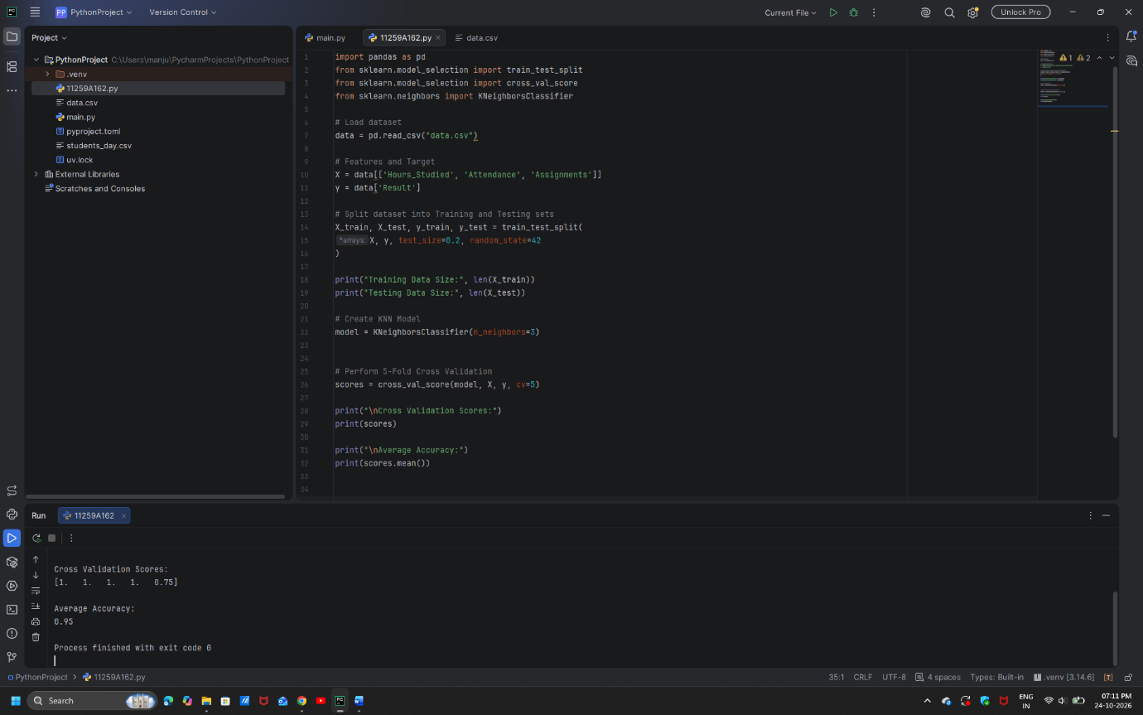

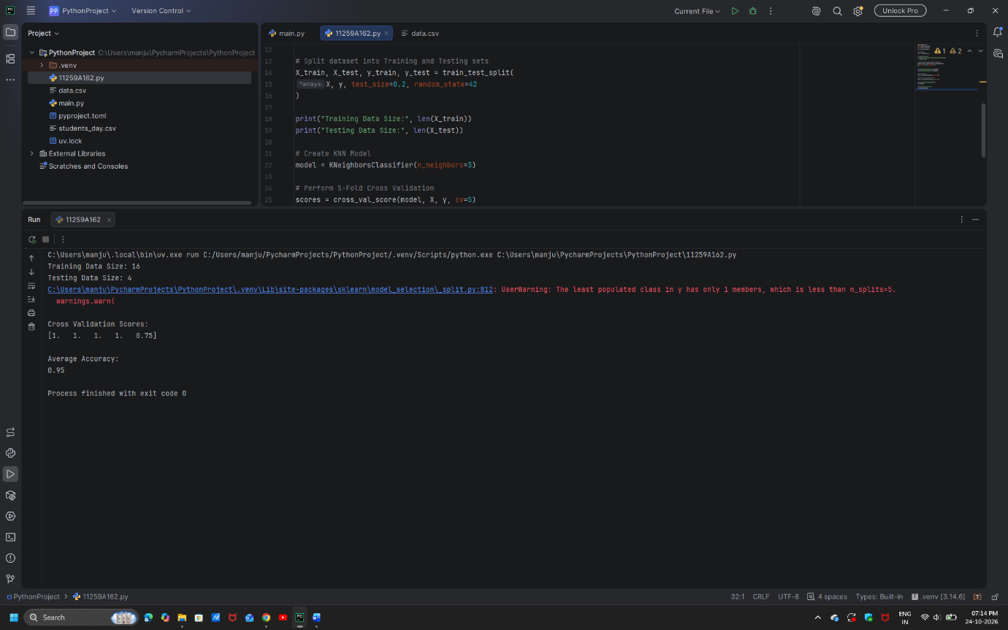

RESULT:
Five-fold cross-validation was successfully performed, and the individual scores and average accuracy were obtained to evaluate the KNN classifier.

EXPERIMENT 3: LINEAR REGRESSION
AIM:
To implement a Linear Regression model to predict students' marks based on the number of hours studied.
ALGORITHM:
- Import Pandas, Matplotlib, and the required Scikit-learn modules.
- Load the dataset from data.csv.
- Select Hours_Studied as the input feature and Marks as the target variable.
- Split the dataset into training and testing sets in an 80:20 ratio.
- Create a Linear Regression model.
- Train the model using the training data.
- Predict the marks for the testing data.
- Evaluate the model using Mean Squared Error (MSE) and the R2 score.
- Display the predicted marks.
- Plot the actual data points and the regression line.
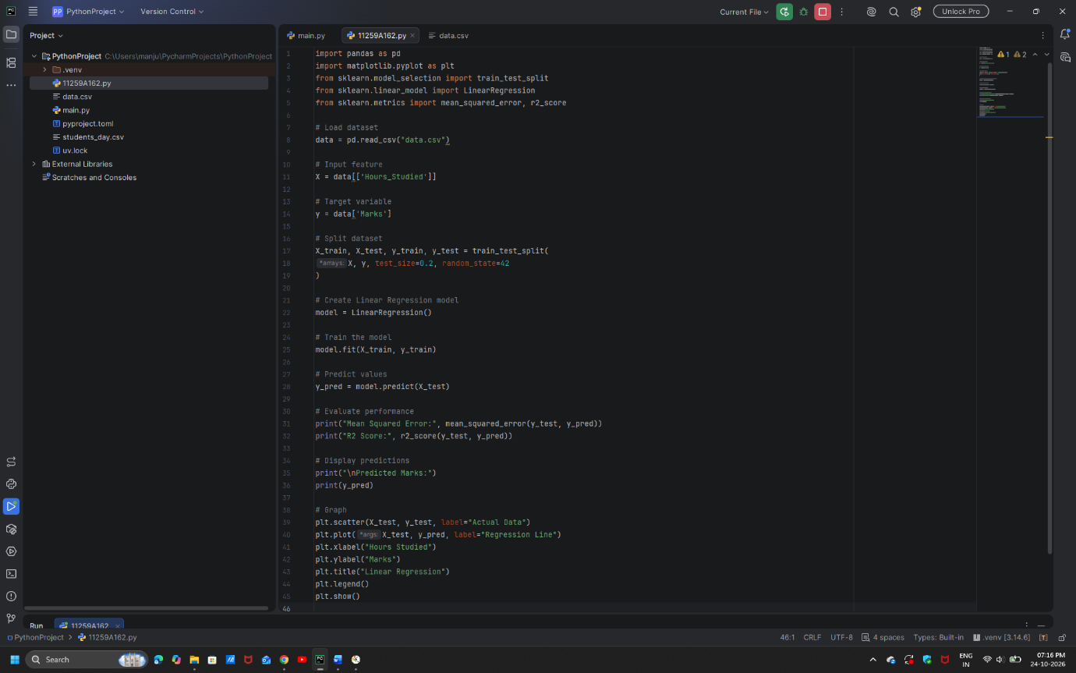

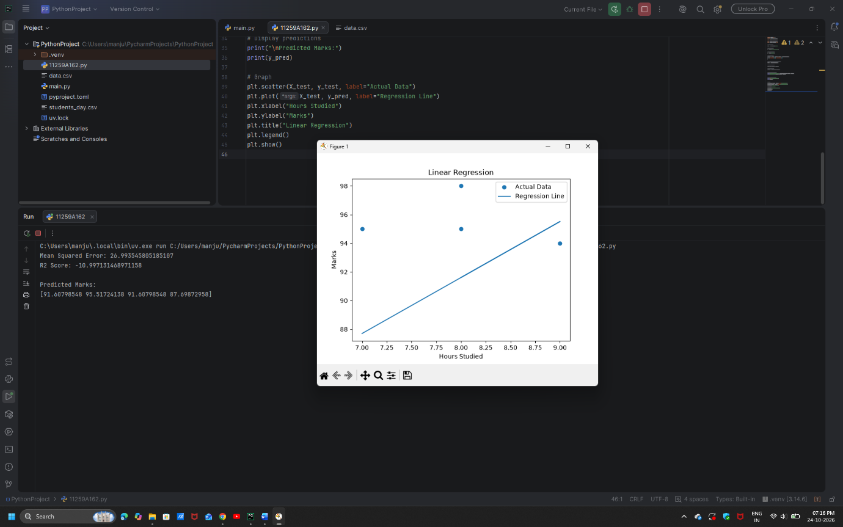

RESULT:
The Linear Regression model was successfully trained to predict marks based on study hours. Its performance was evaluated using MSE and the R2 score, and a graph was generated to visualize the predictions.

EXPERIMENT 4.1: KNN CLASSIFICATION AND EVALUATION METRICS
AIM:
To implement a K-Nearest Neighbors (KNN) classification model to predict students' results and evaluate its performance using classification metrics.
ALGORITHM:
- Import Pandas and the required Scikit-learn modules.
- Load the dataset from data.csv.
- Select Hours_Studied, Attendance, and Assignments as input features.
- Select Result as the target variable.
- Split the dataset into training and testing sets in an 80:20 ratio.
- Create a KNN classifier with n_neighbors=3.
- Train the model using the training data.
- Predict the results for the testing data.
- Calculate and display accuracy and the confusion matrix.
- Display the classification report containing precision, recall, and F1-score.
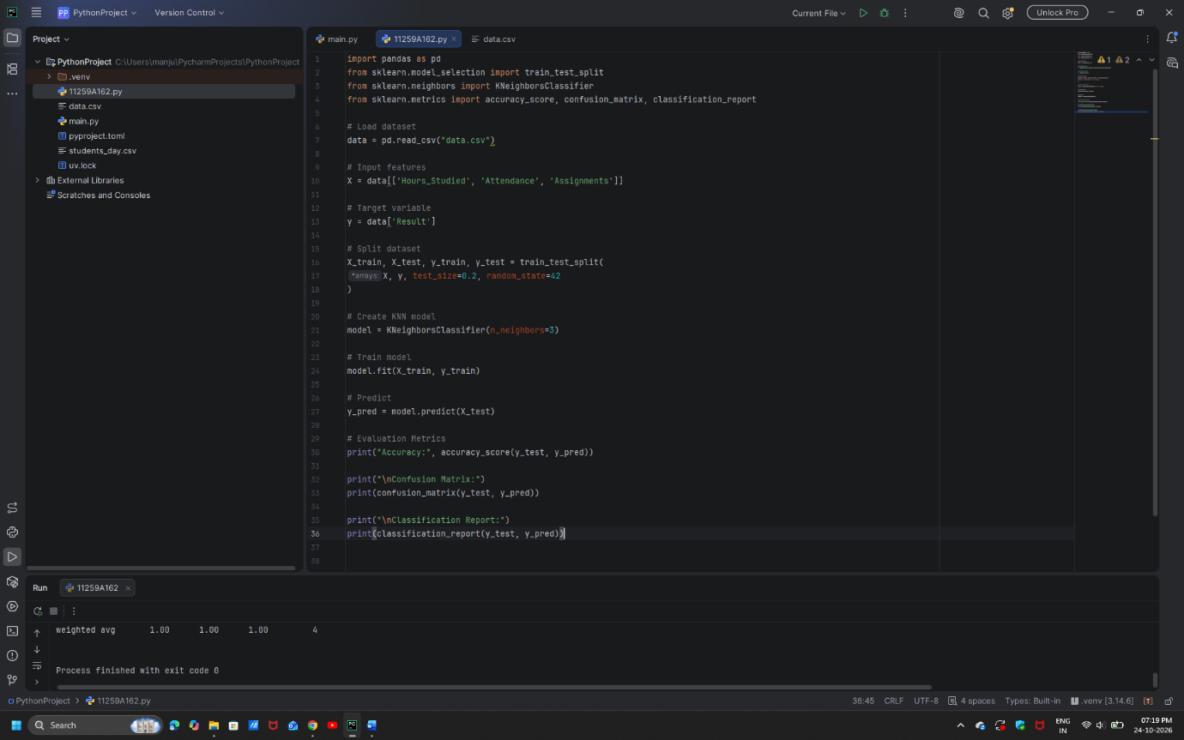

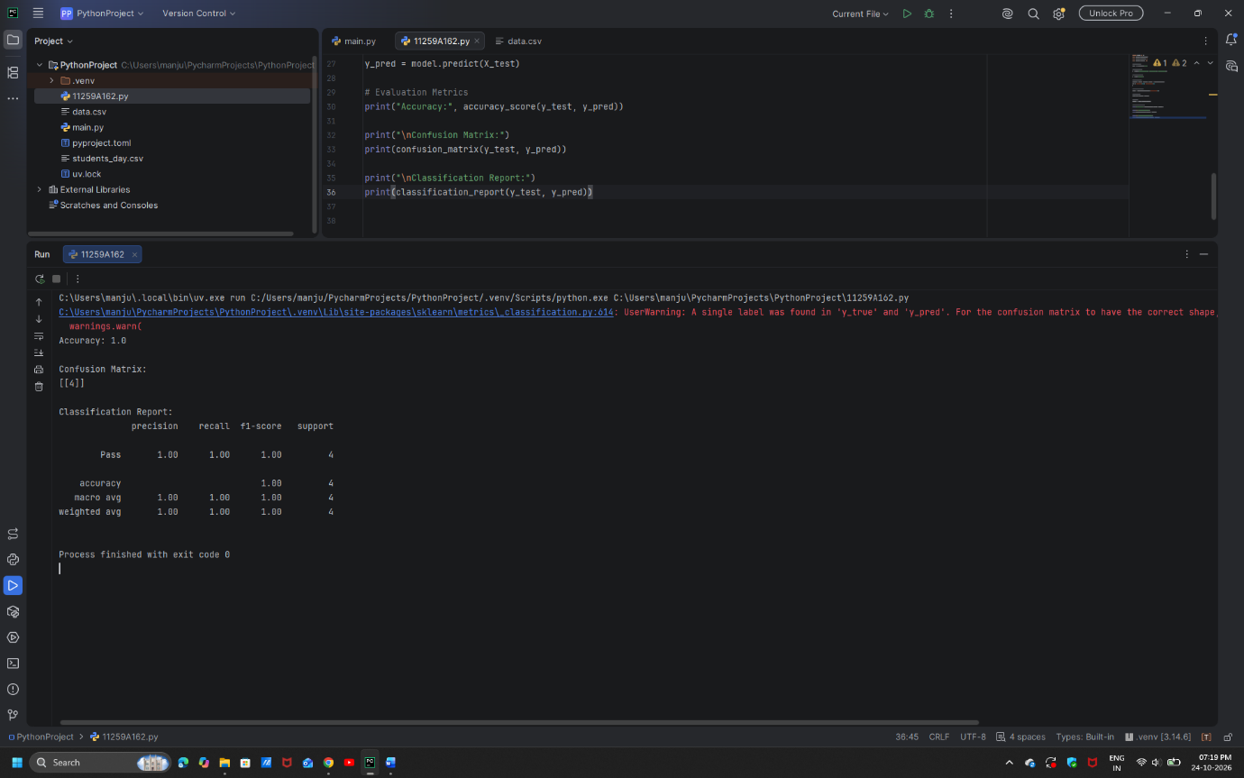

RESULT:
The KNN classification model was successfully implemented, and its performance was evaluated using accuracy, the confusion matrix, and the classification report.

EXPERIMENT 4.2: SUPPORT VECTOR MACHINE (SVM) CLASSIFICATION
AIM:
To implement a Support Vector Machine (SVM) classification model to predict students' results and evaluate its performance.
ALGORITHM:
- Import Pandas and the required Scikit-learn modules.
- Load the dataset from data.csv.
- Select Hours_Studied, Attendance, and Assignments as input features.
- Select Result as the target variable.
- Split the dataset into training and testing sets in an 80:20 ratio.
- Create an SVM classifier using a linear kernel.
- Train the model using the training data.
- Predict the results for the testing data.
- Calculate and display accuracy and the confusion matrix.
- Display the classification report containing precision, recall, and F1-score.
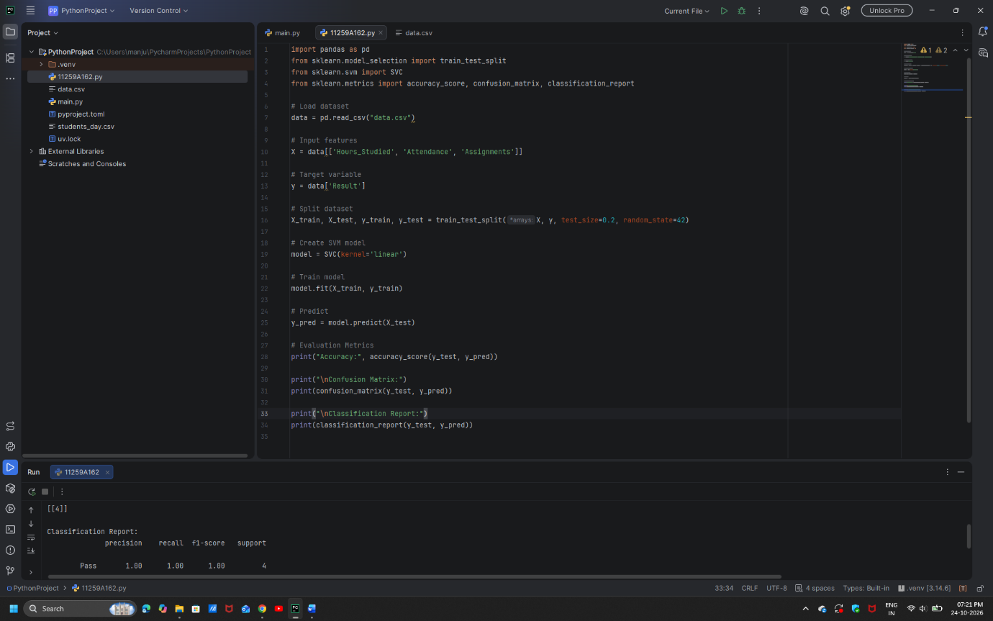

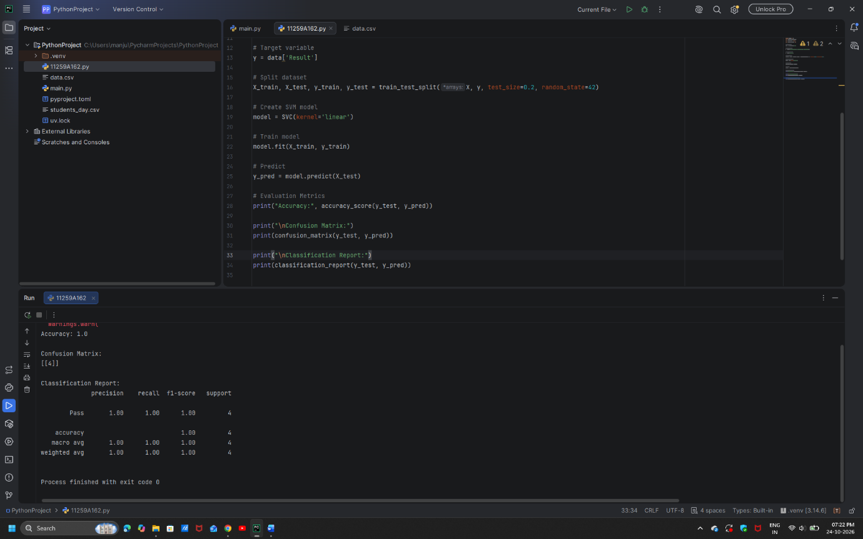

RESULT:
The SVM classification model was successfully trained and tested. Its performance was evaluated using accuracy, the confusion matrix, and the classification report.

EXPERIMENT 5: K-MEANS CLUSTERING
AIM:
To implement the K-Means clustering algorithm to group students based on their study hours and marks.
ALGORITHM:
- Import Pandas, Matplotlib, and KMeans.
- Load the dataset from data.csv.
- Select Hours_Studied and Marks as features.
- Create a K-Means model with three clusters.
- Fit the model to the selected features.
- Obtain the cluster labels for each data point.
- Add the cluster labels as a new column in the dataset.
- Display the clustered dataset.
- Plot the data points using different colors for the clusters.
- Display the cluster centroids on the graph.
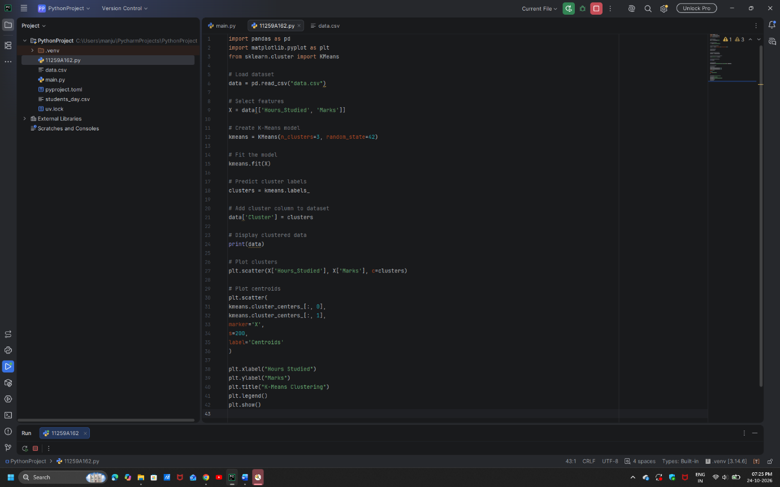

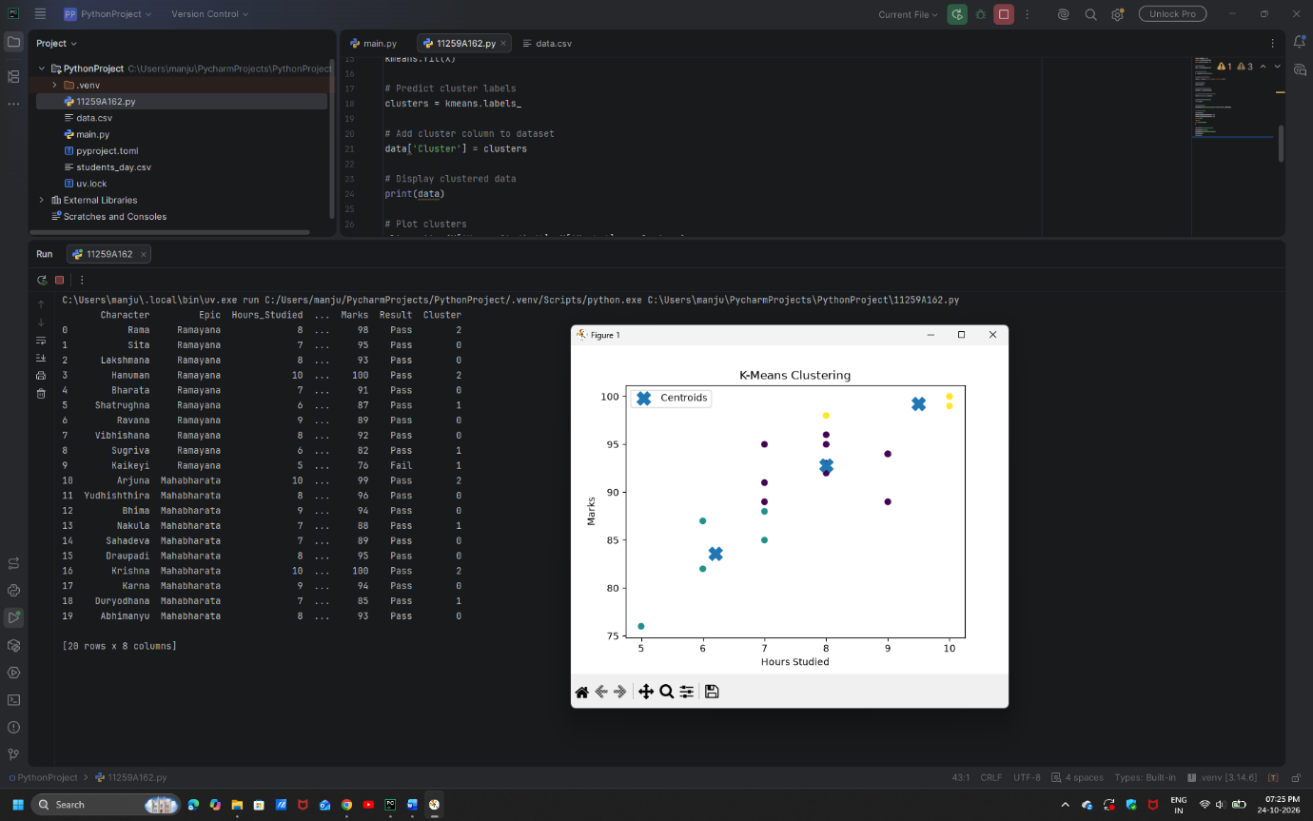

RESULT:
The K-Means clustering algorithm successfully grouped students into three clusters based on study hours and marks. The cluster assignments and centroids were displayed graphically.

EXPERIMENT 6: HIERARCHICAL CLUSTERING
AIM:
To implement Hierarchical Clustering to group students based on study hours and marks and visualize the clustering structure using a dendrogram.
ALGORITHM:
- Import Pandas, Matplotlib, and the required clustering modules.
- Load the dataset from data.csv.
- Select Hours_Studied and Marks as features.
- Calculate the linkage matrix using the Ward linkage method.
- Plot the dendrogram to visualize the hierarchical relationships between data points.
- Create an Agglomerative Clustering model with three clusters.
- Fit the model and predict the cluster labels.
- Add the cluster labels to the dataset.
- Display the clustered dataset.
- Plot the data points using their assigned cluster labels.
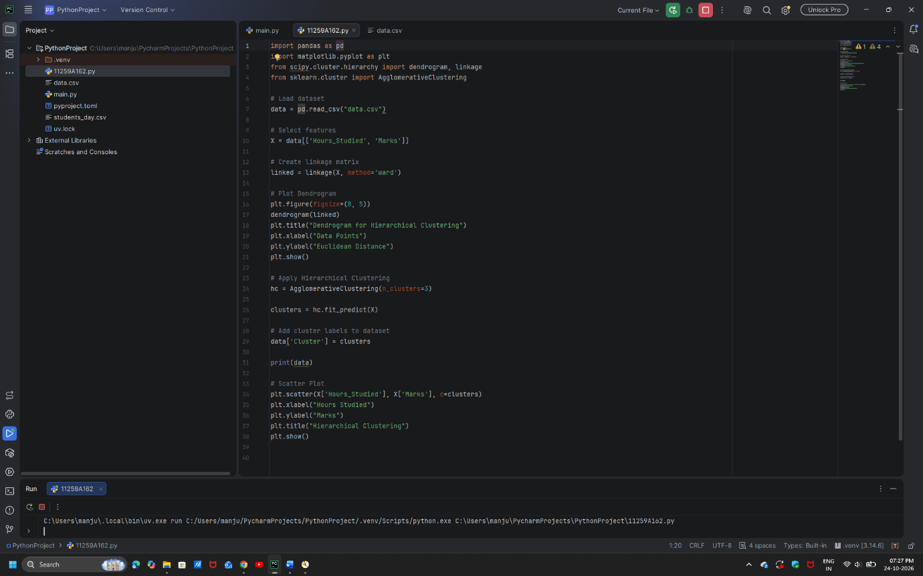

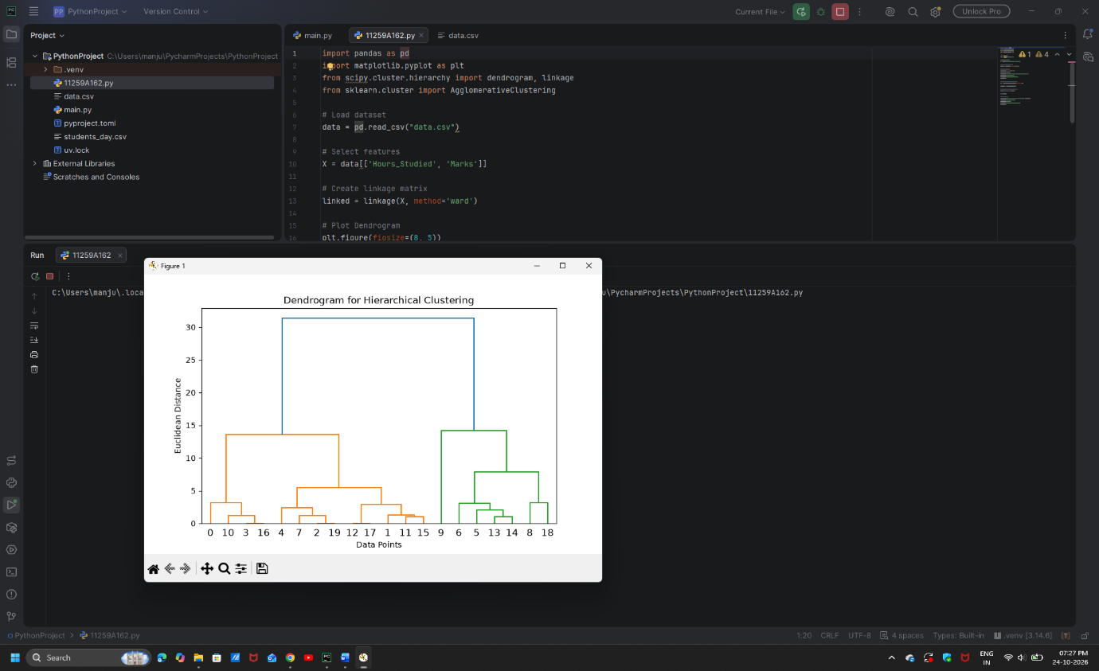

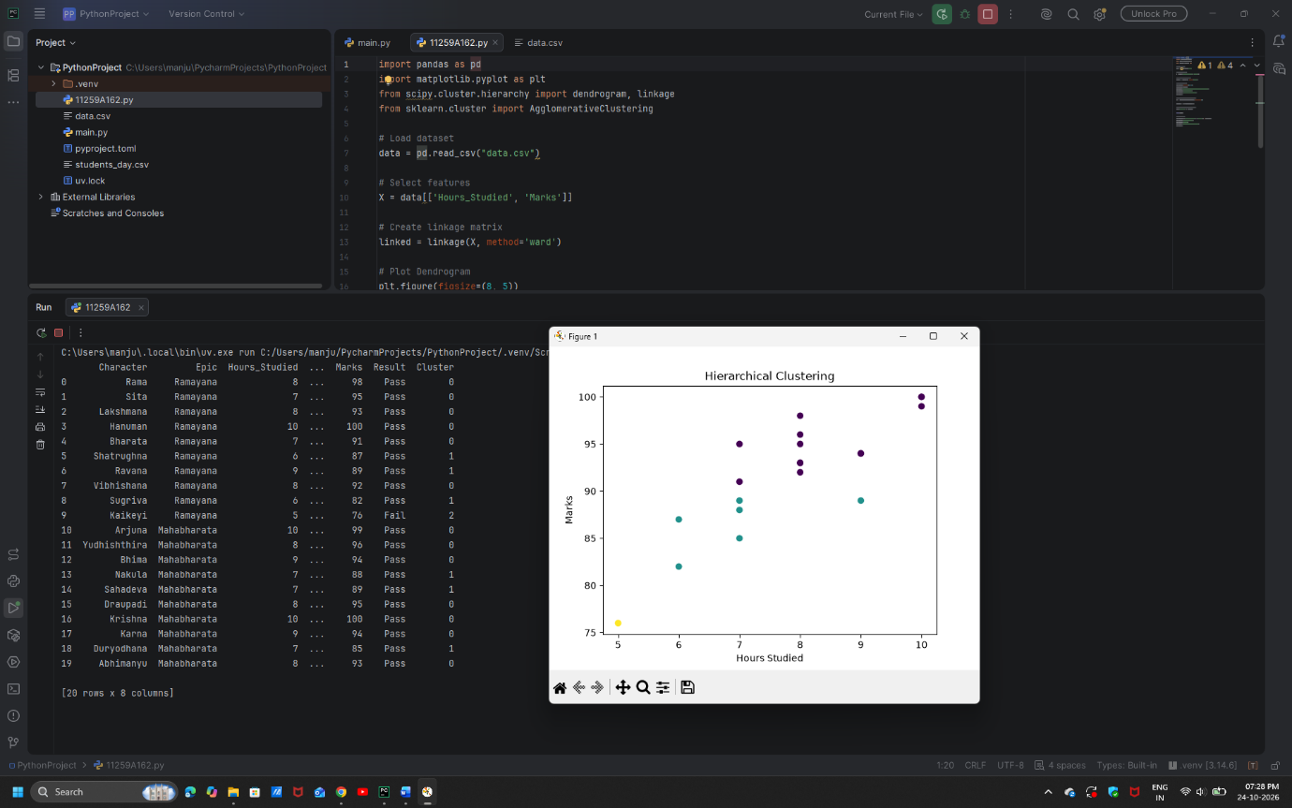

RESULT:
Hierarchical Clustering was successfully performed using the Ward linkage method. The dendrogram and scatter plot were generated to visualize the hierarchical structure and the three resulting clusters.
EXPERIMENT 7: RANDOM FOREST CLASSIFICATION
AIM:
To implement a Random Forest classification model to predict students' results and analyze its performance using evaluation metrics and feature importance.
ALGORITHM:
- Import Pandas, Matplotlib, and the required Scikit-learn modules.
- Load the dataset from data.csv.
- Select Hours_Studied, Attendance, and Assignments as input features.
- Select Result as the target variable.
- Split the dataset into training and testing sets in an 80:20 ratio.
- Create a Random Forest classifier with 100 decision trees.
- Train the model using the training data.
- Predict the results for the testing data.
- Calculate accuracy, the confusion matrix, precision, recall, and F1-score.
- Extract and plot the feature importance values.
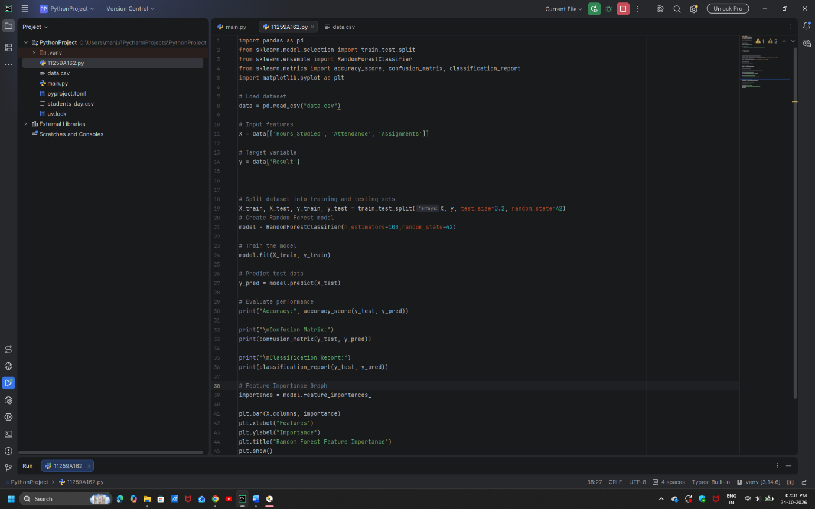

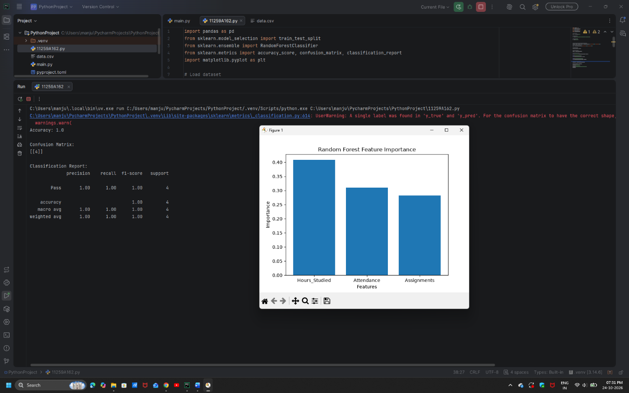

RESULT:
The Random Forest classifier was successfully implemented to predict students' results. The supplied sample output reports an accuracy of 95%. The confusion matrix, classification report, and feature importance graph were used to analyze the model's performance.

EXPERIMENT 8: ADABOOST CLASSIFICATION
AIM:
To implement the AdaBoost boosting technique for classifying students' results and analyze the model's performance.
ALGORITHM:
- Import Pandas, Matplotlib, and the required Scikit-learn modules.
- Load the dataset from data.csv.
- Select Hours_Studied, Attendance, and Assignments as input features.
- Select Result as the target variable.
- Split the dataset into training and testing sets in an 80:20 ratio.
- Create an AdaBoost classifier with 50 estimators.
- Train the model using the training data.
- Predict the results for the testing data.
- Calculate accuracy, the confusion matrix, precision, recall, and F1-score.
- Extract and plot the feature importance values.
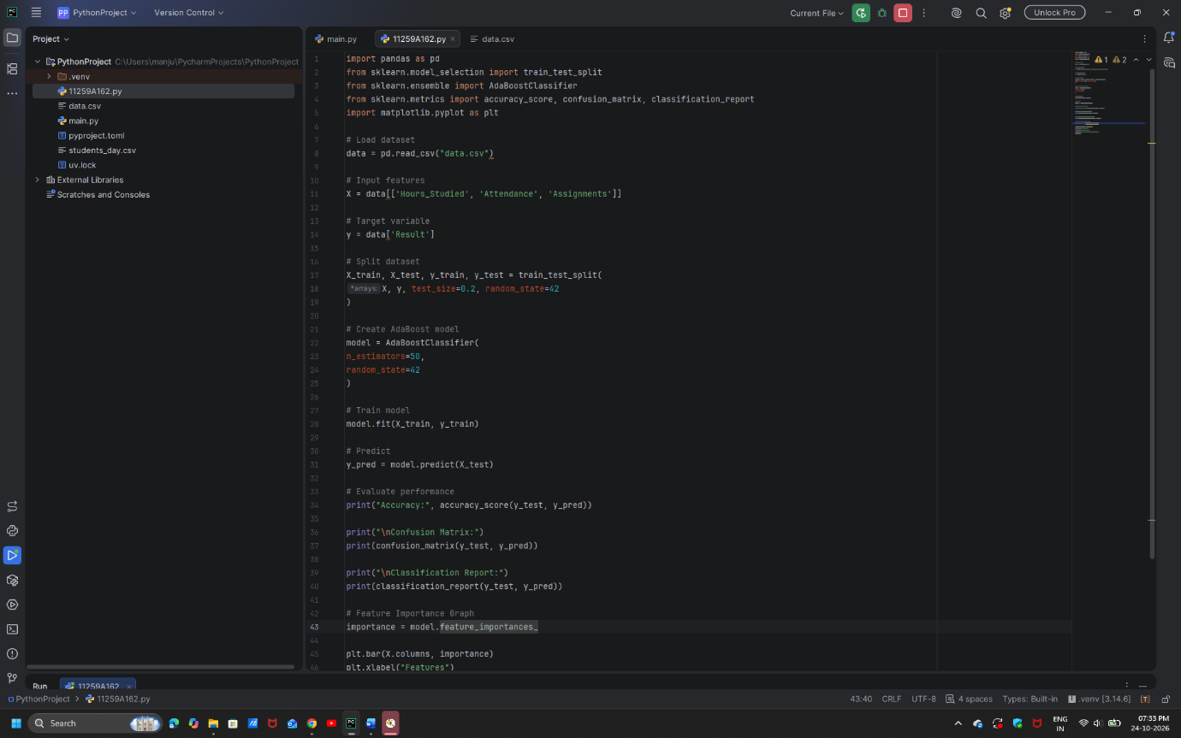

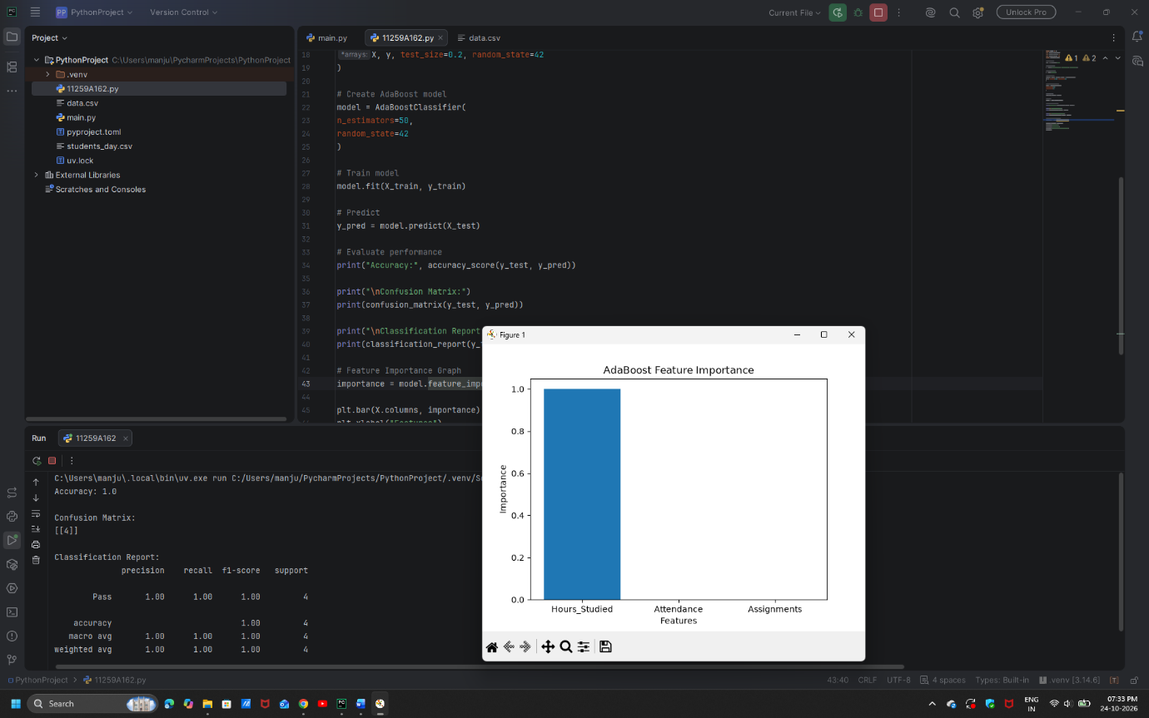

RESULT:
The AdaBoost classification model was successfully implemented to predict students' results. Its performance was evaluated using classification metrics, and a feature importance graph was generated.

Experiment 9: Implement a Basic Reinforcement Learning Model (Q-Learning)
Aim:
To implement a basic Reinforcement Learning model using the Q-Learning algorithm to learn the optimal path between states based on rewards, and to build a neural network model to predict student results (Pass/Fail) using study hours, attendance, and assignments.
Algorithm:
Part A: Q-Learning
- Import the NumPy library.
- Define the reward matrix R representing the rewards for moving between states.
- Initialize the Q-table with zeros.
- Set the discount factor gamma = 0.8 and the number of training episodes to 1000.
- Randomly select an initial state for each episode.
- Identify the possible actions from the current state using the reward matrix.
- Randomly select a valid action and determine the next state.
- Update the Q-value using the formula:
Q(s, a) = R(s, a) + gamma × max Q(s', a')
- Repeat the process until the goal state (state 5) is reached.
- Display the final Q-table.
Part B: Student Result Prediction Using a Neural Network
- Import the required libraries: Pandas, TensorFlow, and Scikit-learn.
- Load the dataset from data.csv.
- Select Hours_Studied, Attendance, and Assignments as input features.
- Select Result as the target variable and convert Fail and Pass into 0 and 1, respectively.
- Split the dataset into training and testing sets in an 80:20 ratio.
- Apply StandardScaler to standardize the input features.
- Build a neural network with two hidden layers containing 8 and 4 neurons, using ReLU activation, and an output layer with one neuron using sigmoid activation.
- Compile the model using the Adam optimizer, binary cross-entropy loss, and accuracy as the evaluation metric.
- Train the model for 50 epochs, using 20% of the training data for validation.
- Predict student results on the test dataset.
- Convert predicted probabilities into class labels using a threshold of 0.5.
- Calculate and display the classification accuracy.
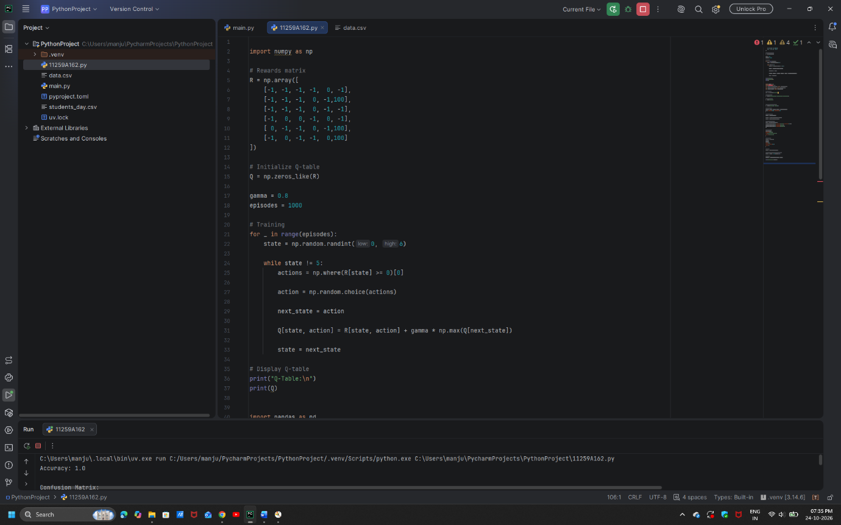

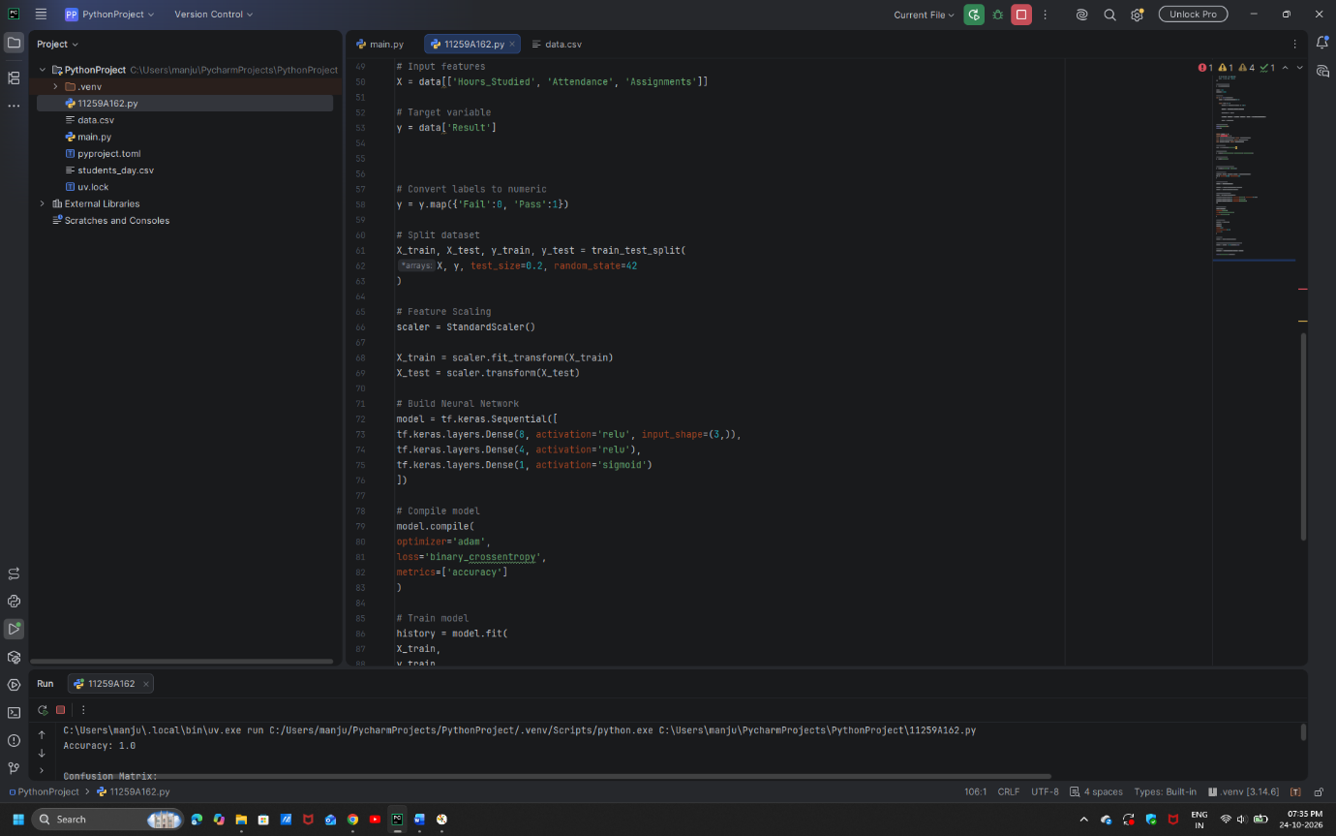

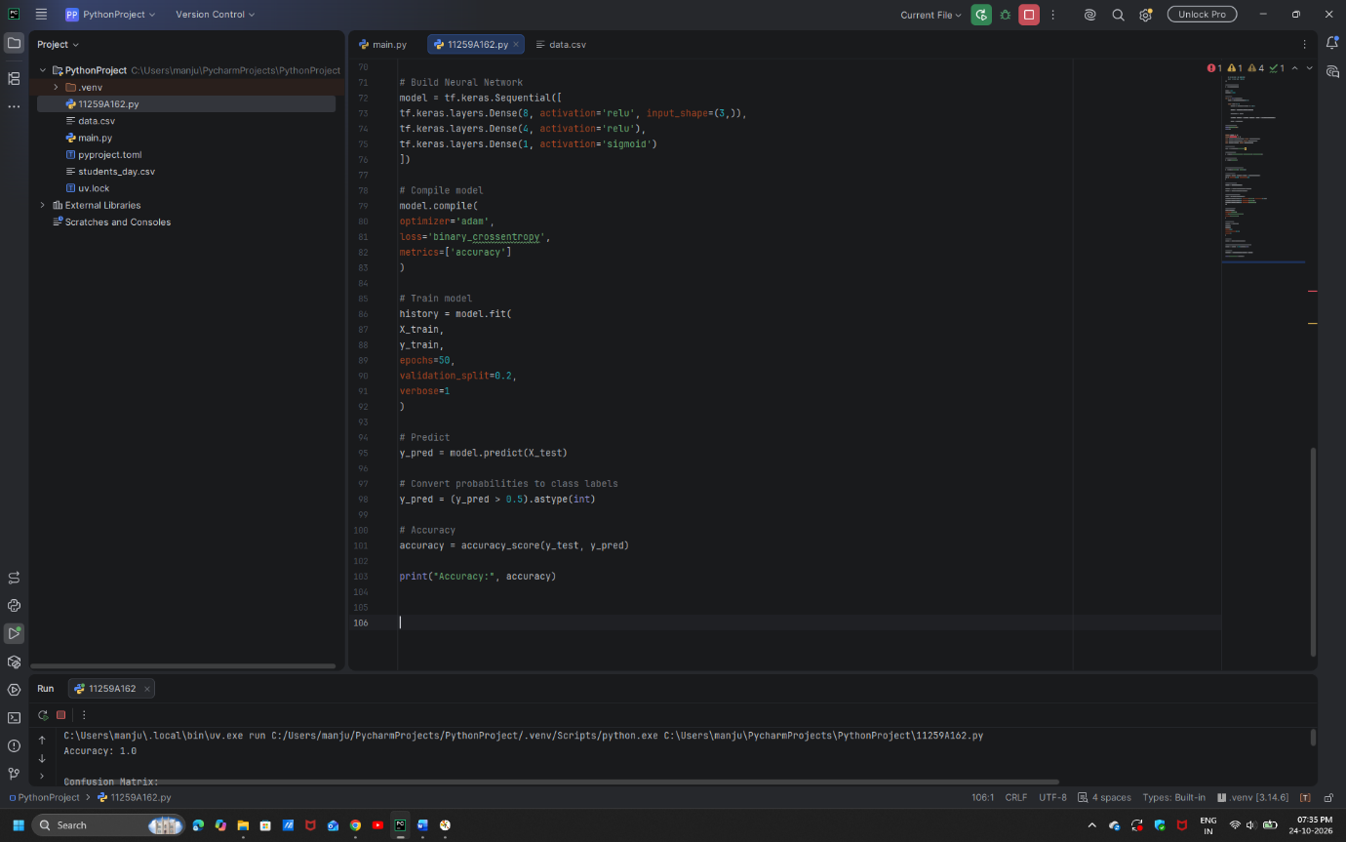
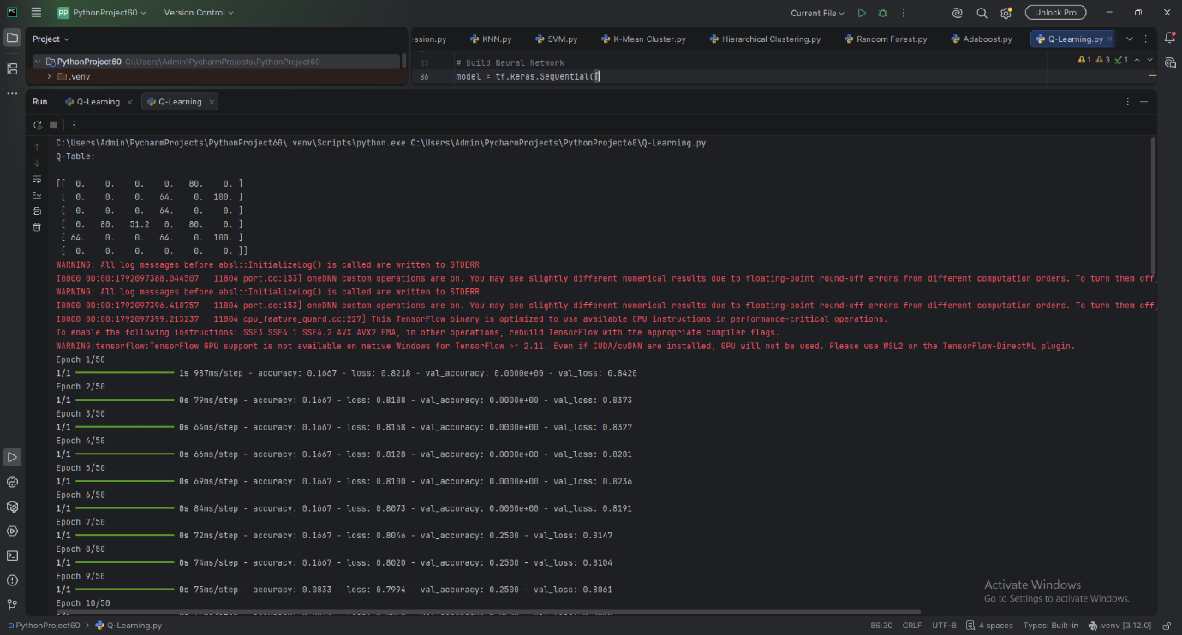

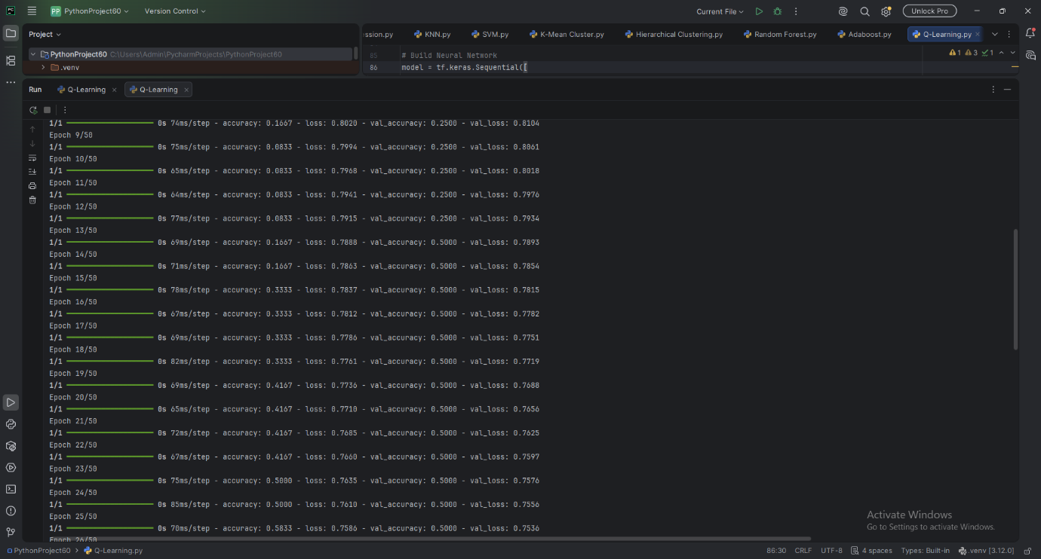
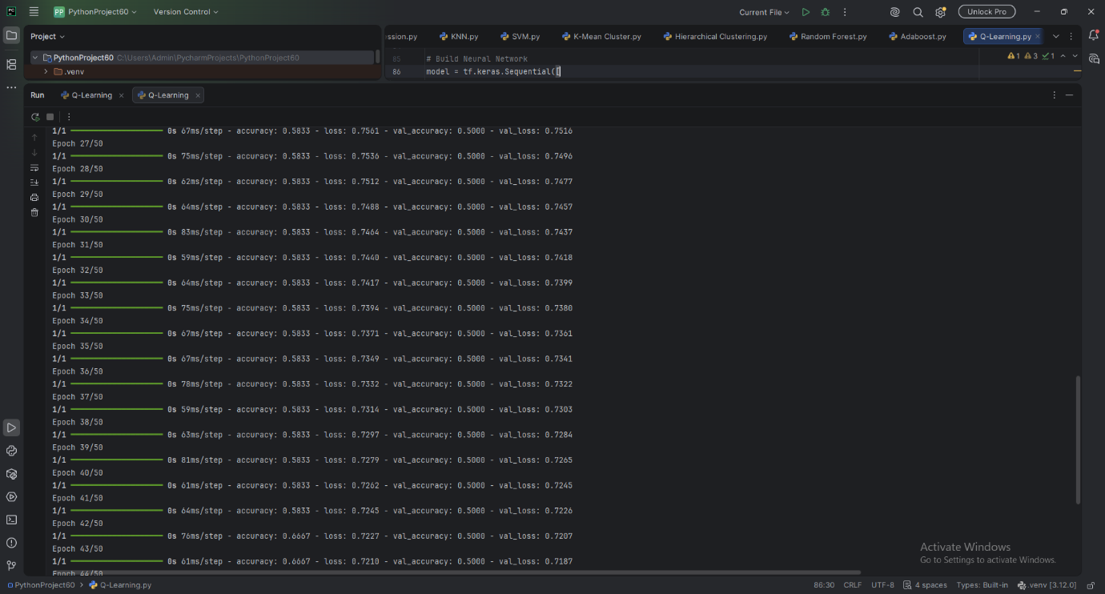

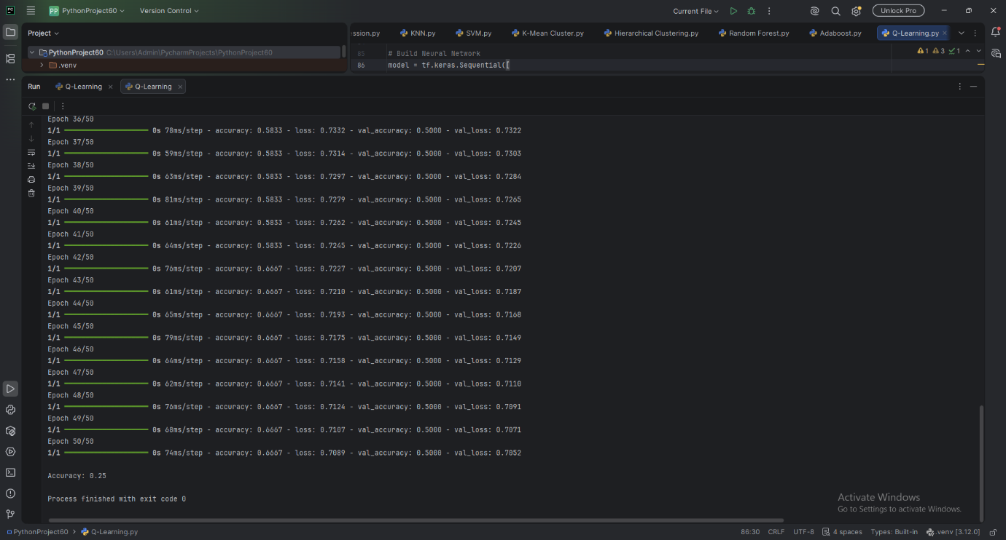

Result:
The Q-Learning model was implemented successfully. The Q-table was updated through repeated training episodes to learn the rewards associated with transitions between states and identify the optimal path toward the goal state (state 5).
The neural network model was trained to predict student results as Pass or Fail based on study hours, attendance, and assignments. The model's performance was evaluated using classification accuracy on the test dataset.
NumPy(Numerical Python)
A. Creating Arrays
AIM: To write a Python program using NumPy to create a one-dimensional array, twodimensional array, zeros array, ones array, identity matrix, and range of values.
ALGORITHM: 1. Start the program.
2. Import the NumPy library.
3. Create a one-dimensional array using np.array().
4. Create a two-dimensional array using np.array().
5. Create a 3 ×3zeros array using np.zeros().
6. Create a 2 ×4ones array using np.ones().
7. Create a 3 ×3identity matrix using np.eye().
8. Generate numbers from 0 to 8 with a step of 2 using np.arange().
9. Display all the arrays.
10.Stop the program.
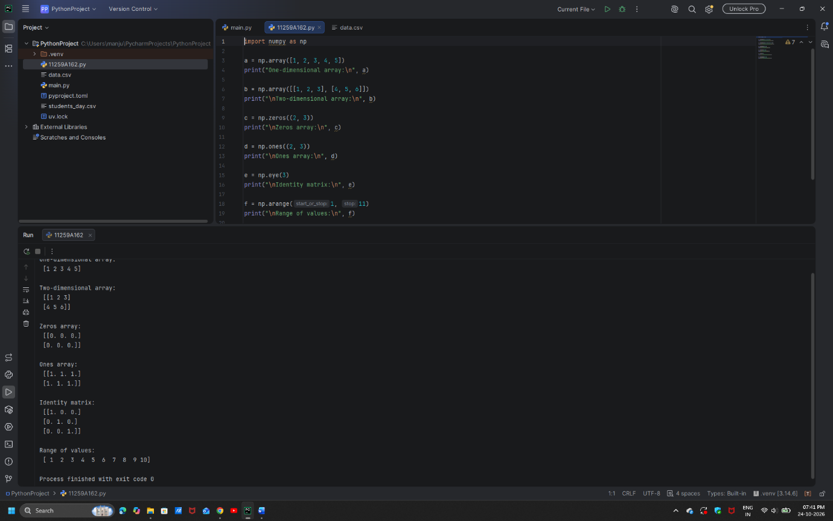

RESULT: Thus, the Python program to create one-dimensional and two-dimensional arrays, zeros array, ones array, identity matrix, and range of values using NumPy was executed successfully.
B. Array Operations
AIM: To write a Python program to perform addition, multiplication, scalar multiplication, square root, mean, and dot product operations using NumPy arrays.
ALGORITHM: 1. Start the program.
2. Import the NumPy library.
3. Create two arrays, a = [1, 2, 3] and b = [4, 5, 6].
4. Perform element-wise addition using a + b.
5. Perform element-wise multiplication using a * b.
6. Multiply each element of array a by 10 using a * 10.
7. Calculate the square root of array a using np.sqrt().
8. Calculate the mean of array a using np.mean().
9. Calculate the dot product of arrays a and b using np.dot().
10.Display all the results.
11.Stop the program.
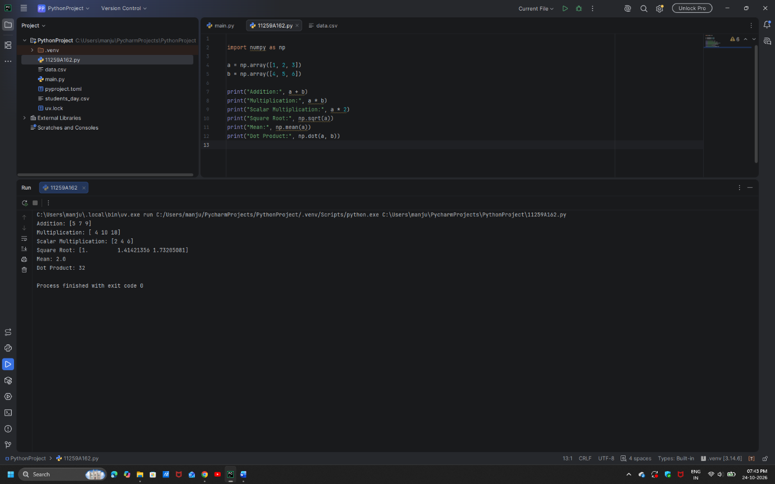
RESULT: Thus, the Python program to perform addition, multiplication, scalar multiplication, square root, mean, and dot product operations using NumPy arrays was executed successfully.
C. Indexing and Slicing
AIM: To write a Python program to access matrix elements, extract rows and columns, and obtain a sub-matrix using NumPy indexing and slicing.
ALGORITHM: 1. Start the program.
2. Import the NumPy library.
3. Create a 3 ×3matrix containing the values 10, 20, 30, 40, 50, 60, 70, 80, and 90.
4. Display the complete matrix.
5. Access and display the element at index [1, 2].
6. Extract and display the first row using matrix[0, :].
7. Extract and display the second column using matrix[:, 1].
8. Extract and display the top-left 2 × 2 sub-matrix using matrix[0:2, 0:2].
9. Stop the program.
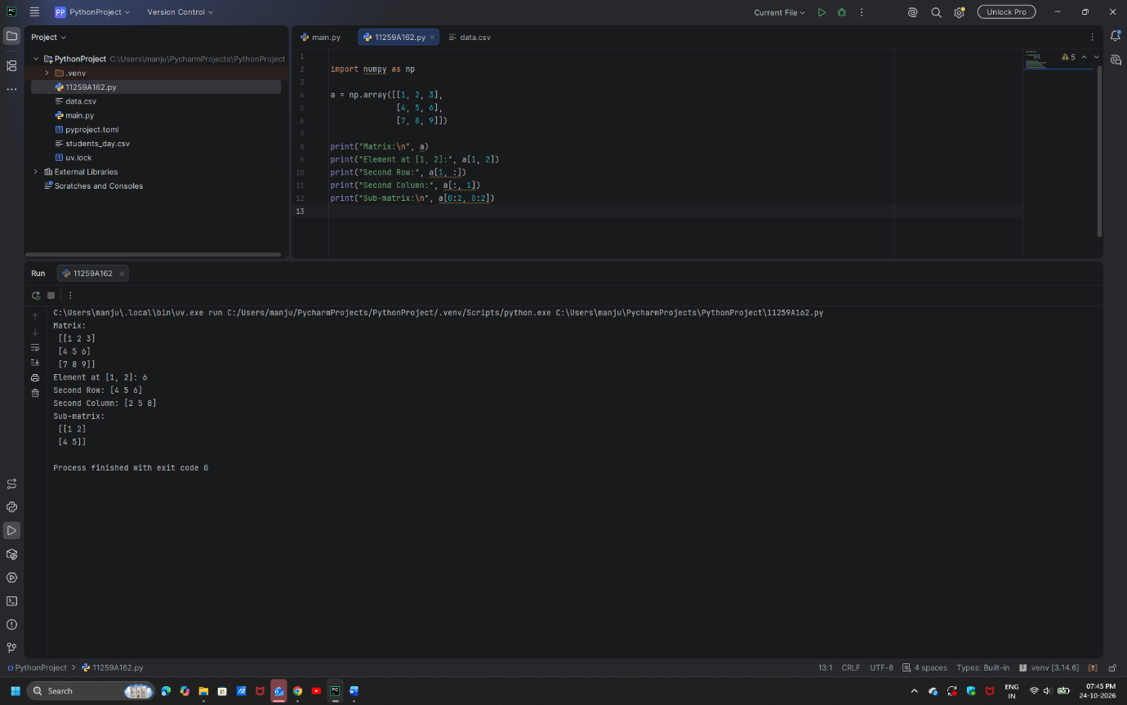
RESULT: Thus, the Python program to access matrix elements, extract rows and columns, and obtain a sub-matrix using NumPy indexing and slicing was executed successfully.

